“What becomes of the broken hearted”: Game Design Document

# Classification

* Genre: narratively explorable escape room
* Platform: PC
* Target Group: Mature audience

# Story

Diego’s heart is broken into pieces after breaking up with their abusive partner, Taylor. The three pieces of his heart are now governed by three negative emotions. Anxiety is now tasked to deal with this situation.

This game deals with Diego having to do a big decision, you as the player control whether you heal or destroy his heart. As the player you get an insight into how his last relationship was through the flavor text of the items in the escape rooms. How the relationship works and game looks will shift gradually over time, in the same way that a good relationship gradually turns abusive so does our game; we also want to convey this feeling towards the relationship by keeping the abusiveness of the partner a secret until midway through the game.

# Narrative Goal

We believe that the abuse of men goes greatly unnoticed in today’s society and that it is also greatly underrepresented in media. Telling a story where a man is a victim of abuse could help the players of this game become more aware of how abuse has no gender. Hopefully this would also potentially break down toxic masculinity by portraying a man who is weak and can’t stand up for himself.

# Gameplay

To progress in the game, you need to escape from several rooms within the heart. You may choose to solve the puzzles in each room and comfort each of the emotions with the help of narrative clues in the environment. However, you may also choose to destroy the puzzles and murder these negative emotions.

Every level you can speak with the emotion of said level. This will give the player insight into what Diego is feeling while also giving a sort of quest. These quests will ask you to prove something to them with an item, this item is the last thing you unlock in the escape room, giving the player a reason behind their actions and moving the plot forwards.

# Story-Gameplay Balance or Level Structure

**Stairs:** One key aspect about our game is our usage of stairs to connect things. Stairs will be used to connect levels, visuals and story between each segment of our game.

When a player is walking on stairs after a while, they have the control of the character taken away from them, then a cinematic moment starts where the outside story is shared to the player while their character slowly approaches the next level. On these moments the player may have the ability to choose alternate story details that are actually unimportant, being able to do this may be cut due to time constraints

**Environment Order:**

-Cloud for ambience and as movement teaching moment

-Stairs for exposition

-First Level, Library. Game play and exposition

-Stairs

-Second Level, Greenhouse.

-Stairs

-Third Level, Void

-Ending sequence + Credits

# Unique Selling Point

The unique selling point of this game is that the player can consume the narrative in any way they choose. This way choice is not a game mechanic but rather a product of the player being free in this explorable environment.

# Characters

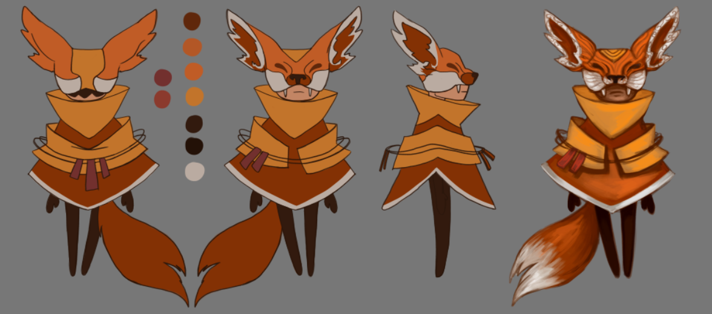

This is Anxiety, our player-controlled character. They are a nervous wreck that tries to keep its cool but fails more often than not.

Anxiety is a very two-sided character, while it tries to protect from harm it often ends up causing harm itself instead. This two-sidedness is just what we needed for our game in which you can heal or destroy the heart of Diego. The reason why we chose the fox to represent anxiety is because foxes are also seen as two-faced: as incredibly intelligent, yet also as traitorous.

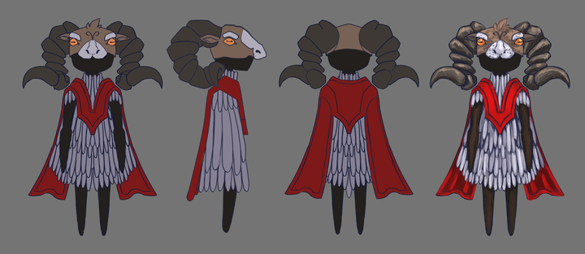

This is Anger, keeper of the library.

Fear, keeper of the Greenhouse; and Sadness, keeper of the void; will be developed later.

# Game Mechanics

**Narrative in items:** Most items in the game will have a narrative reason for being there and will contain information about the outside story that the player may or may not want to read. The goal is to reward the player for exploring the world, while also giving them the option to skip this if they’re not interested in this aspect of the game.

**Interaction item-environment:** Often to advance you to have to use an item on the environment. Like for example say you had the key and wanted to use it on a door. The way this works in game is first you have to the item selected from inventory (the selected item is shown constantly on the top left of the screen) and then click to interact on the desired environment object. Depending on our wishes the item may disappear from the inventory once used.

You may pick up items even though you have an item selected from your inventory.

If you try to interact with an environment that doesn’t react to your item (say for example you click on the door while holding a water bottle) the same message shows as it would if you had no item selected (here for example “This door is locked, I wonder where the key is”)

**Knowledge Test:** The last challenge when finishing a level is a dialogue with the emotion of said level. Narratively the emotion is trying to get you to prove that you care about them by asking you questions about the outer story. As a mechanic what this does is test the player’s knowledge about the outside story, check if they have read the flavor text in the environment and items, and lastly end any misconceptions the player might have picked up about the outer story.

# Setting/Lore

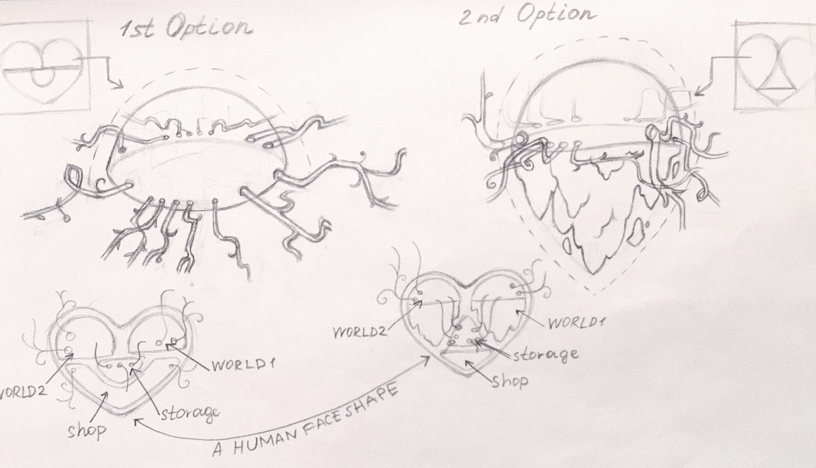

This game’s setting is the broken heart of Diego

# Level Art

## Library Level, Childhood Room

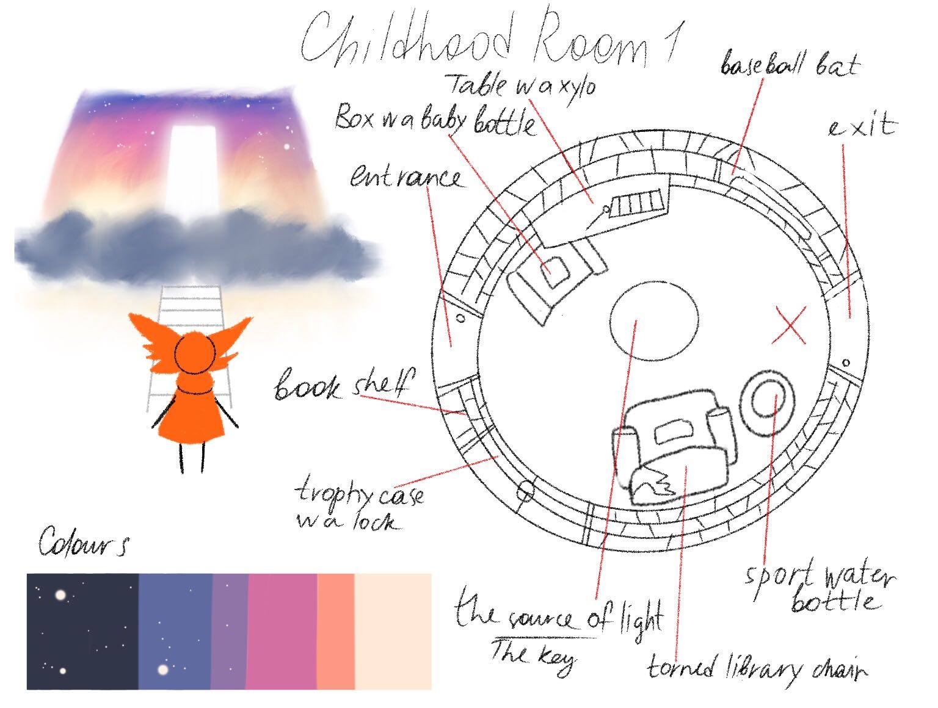

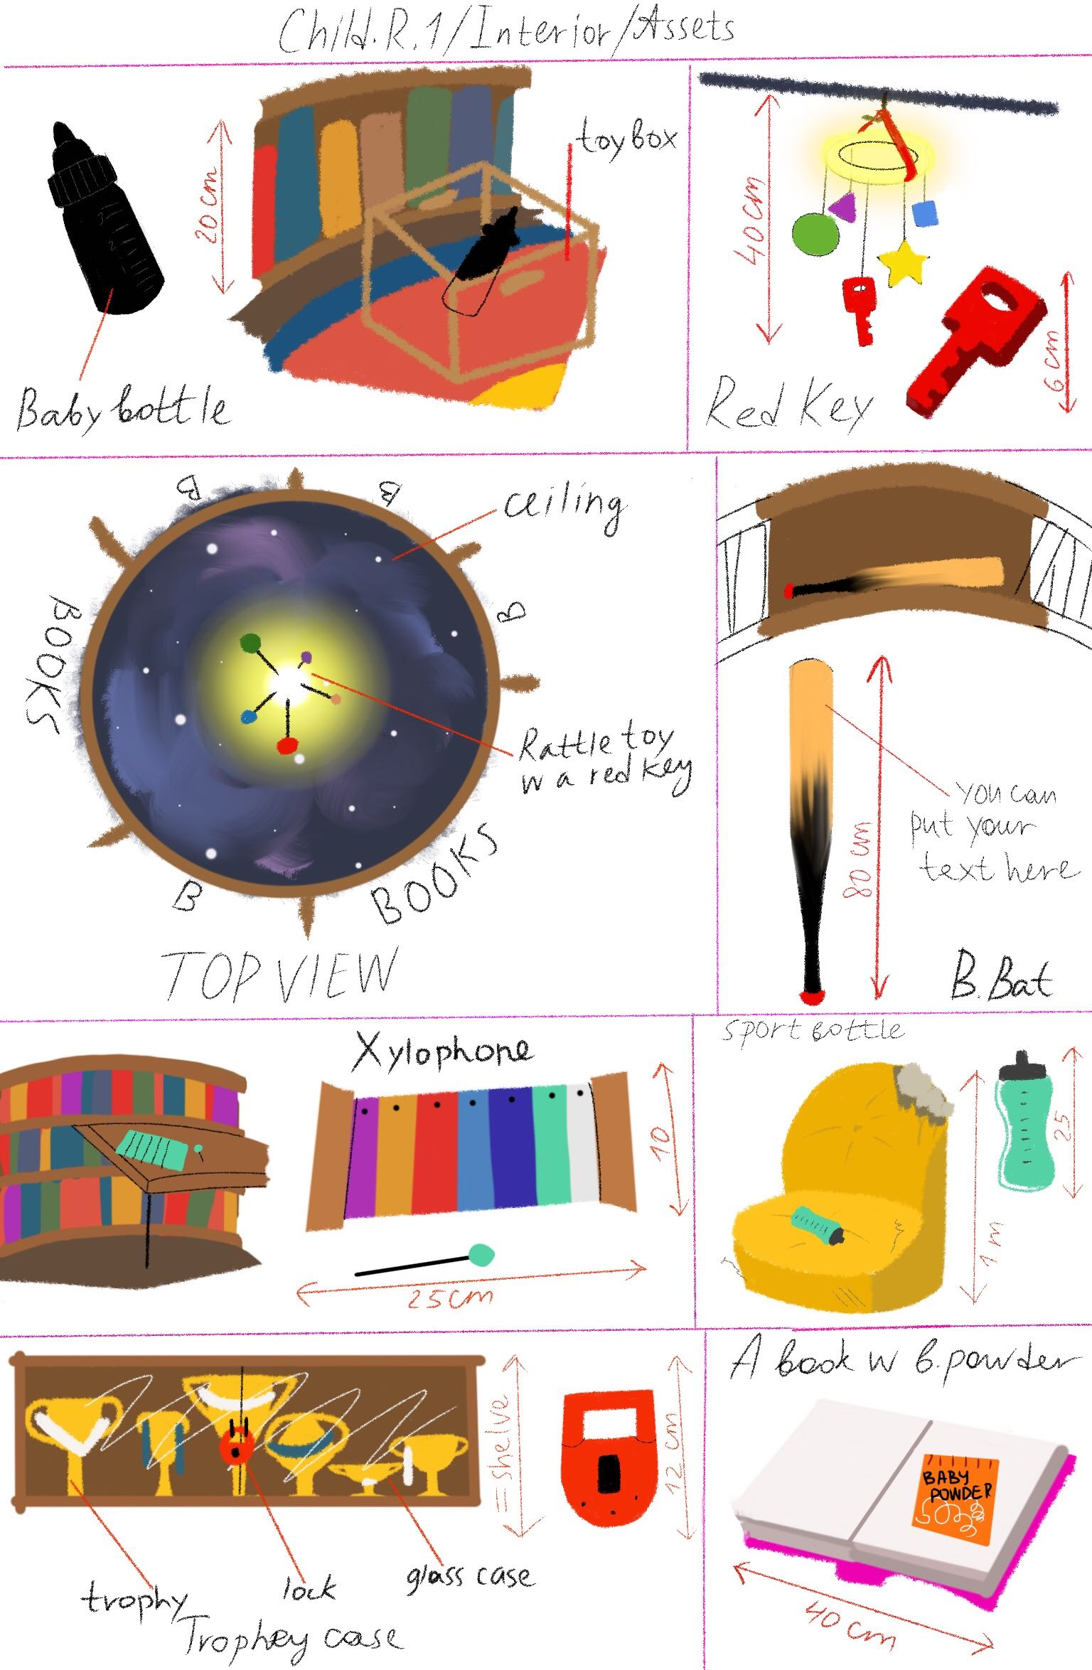

## Library Level, Letters Room

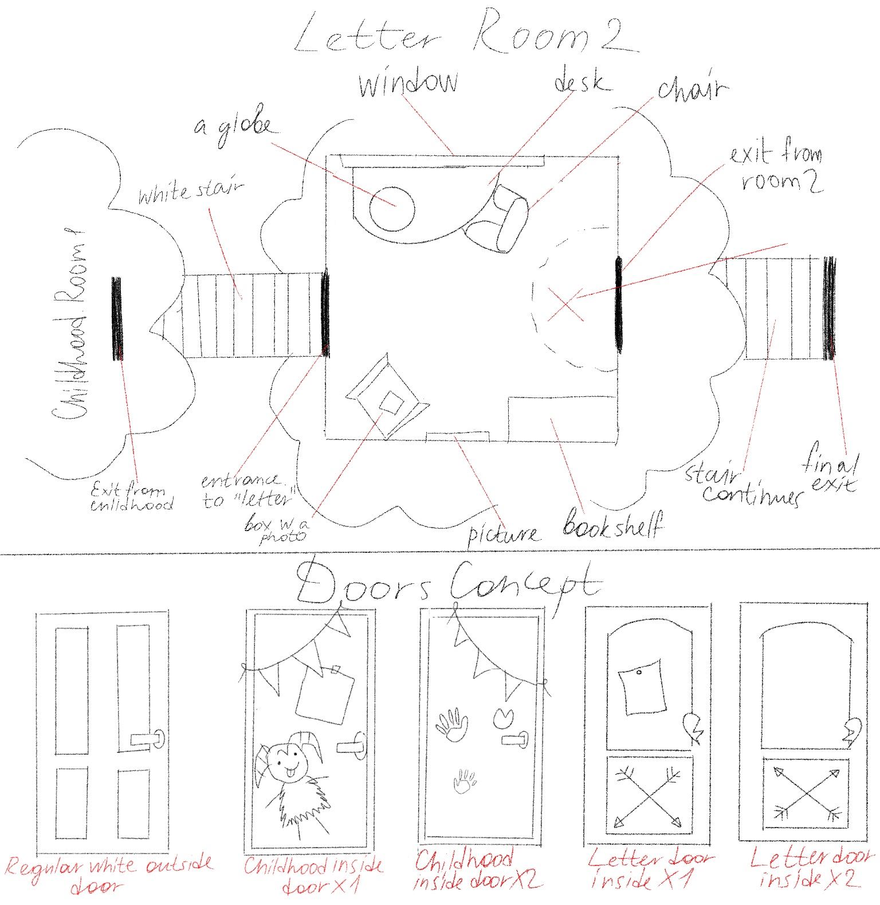

## Greenhouse Level Concept Art

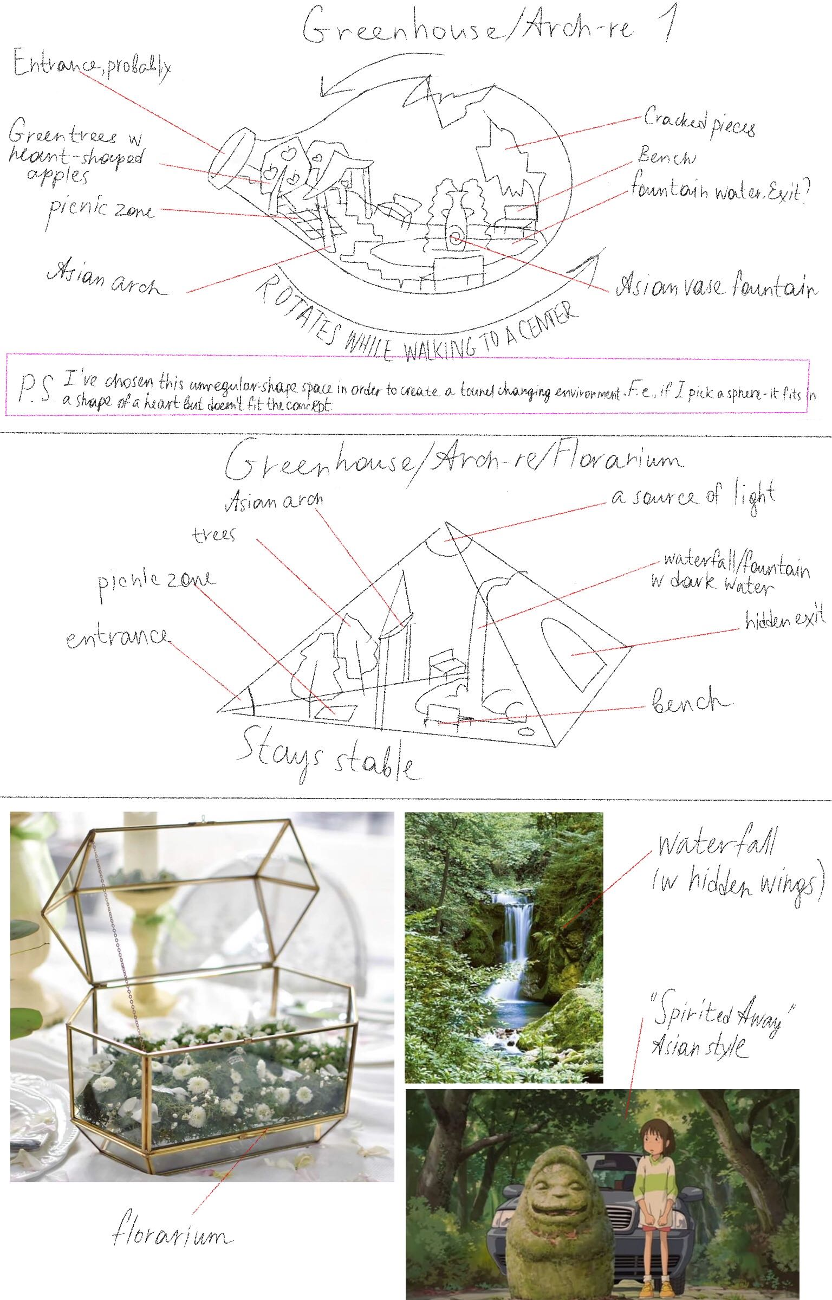

# Multiple Endings

This game features 3 endings that depend on the player’s actions in the game.

**Good Ending:** You solved all the puzzles without the use of weapons and comforted all the emotions. For this reason, Diego is now healed and able to love romantically again.

**Bad Ending:** To get this ending you have to kill all of the emotions.

**Neutral Ending:** To get this ending you have to either break a puzzle with the use of a weapon, murder less than 3 emotions, or fail too many times on the Knowledge Test of each level.

# Controls

**W,A,S,D:** Movement

**Left Click:** Inspect and if applicable, pick up an item

**Right Click:** Use currently held item

**Scroll Wheel:** Change currently held item for the next one in your inventory

**E:** Open an inventory screen, where items can be visually inspected, where the description of items (containing hints when the player is stuck) is displayed

**Shift:** Hold shift to walk faster

# Team Info and Contact

* Alba Josefin Pläp Golfe – Lead and Character Artist

[alba.plaep@gmx.de](mailto:alba.plaep@gmx.de)

* Maria Lobanova – Environmental Artist

[maroosyalmk@gmail.com](mailto:maroosyalmk@gmail.com)

* Ignacio Di Paola – Writer and Designer

[ignaciodipaola@hotmail.com](mailto:ignaciodipaola@hotmail.com)

* Frederyk Wilhelm Sperling – Programmer, Lighting Artist, and Sound Designer

[mail@frederyk.de](mailto:mail@frederyk.de)